University of the Cordilleras

*Gov. Pack Rd., Baguio City*

**PATCH CAFÉ**

**Marketing Strategy Study**

Dumacil, Jamellah P.

Gomez, Renz Rallion T.

Rabang, Eugene G.

CITCS 1L - CC13

**Chapter I: Project Overview**

This study investigates and evaluates different project models for constructing an information system in order to choose and create one to fit the IT management of the case company. In this study, an IT system for communication has been selected as a focus for development.

Project models are evaluated from several viewpoints, and relevant theory is used to create a model that fits the purpose best. The proposed project model is to be positioned in the construction phase between the specification and transition phases.

The sources of the study are the documents, workshop results and expert interviews derived from the case company. With the assistance of the review of literature and case study, the project model is developed to fit the construction of the new information systems in the case company.

**1.1 Background of the Study**

The food industry is highly diverse and comprises several important components. Each component adds distinct value to the whole food chain by improving sustainability and producing better products**.** Lead-time, delivery and sales are directly proportional to the business potential and benefit to the consumer in relation to the shelf life period – expiration. For food companies, therefore, the information system has prepared tools and support, which minimize the phases of production and distribution, and, conversely maximize the length of the selling period.

Patch cafe defines corporate social responsibility as a part of the food industry, conducting business in a way that produce social, environmental and economic benefits to the communities in which they operate. Patch Cafe, manage to innovate and upgrade their marketing strategy and able to compete to its competitors. Patch cafe offers events and promos such as 10 % off and but one takes one’s. This leads to the fast growth of the company, Patch Cafe also uses its business partners for advertisements and promotions.

Every company takes into account trends in the needs of customers and simultaneously an appropriate pricing policy motivates the increased ordering of its products.  Under USDA (U.S. Department of Agriculture) system that operates both national and world agricultural information system. Some general evaluation criteria to use in judging the strengths and weaknesses of information systems such as objectivity, reliability, timeliness, adequacy in terms of coverage, efficiency, and effectiveness. In connection with Patch Cafe, showed that integration of business activities can improve both efficiency and effectiveness of business activities, but also lead to greater dependencies and decrease organizational flexibility. This includes the reliability of the service maintaining the capability of business-marketing strategies.

Marketing strategy represents a key element of success for organizations. Executing an effective marketing strategy is just as important as conceptualizing and creating it. Through marketing strategy implementation firms employ scarce resources through marketing capabilities in order to attain the set goals and targets. In order to achieve a satisfactory and adequate marketing strategy which has a positive outcome on global and overall firm success, the marketing department within a company should bear in mind all the different marketing mix strategies that can influence the comprehensive result and the cumulative firm success.

The companies that uses similar information system through different marketing strategies are the following: Coca-Cola: Brand Consistency, studies from around the world have shown that Coca-Cola is one of the most well-known brands in the world. Today, Coca-Cola owns a huge percentage of the beverage market. Their red and white logo is recognised in countries all around the world and people identify their brand with feeling good and staying refreshed. This just goes to show that when it comes to developing a recognisable and popular brand, consistency can go a very long way as its major marketing strategies; Starbucks: Social Strategy, Starbucks is the perfect example of a business that is crushing it when it comes to social media. Having a strong social media presence is imperative if you want to take your business to the next level. Social media is important as it helps to establish brand identity, authority and trust. It also helps consumers to engage with your brand on a more intimate level, which helps to develop stronger relationships over time.and competitions through their social media platforms and many have gone on to be viral sensations around the web. Most recently, Starbucks became a trending news topic over their red Christmas coffee cups. This was of course no accident, and was a highly orchestrated social media campaign that just happened to go viral; Whole Food Market: Stand for Something.  When Whole Foods first came onto the market there was really nothing like it. Their strategy was to offer one thing and to offer it well, and this has really been the hallmark of their success. Many marketers and business owners get caught up in the idea of trying to please everyone or to be a part of everything, but this can often end in disaster and can leave your brand directionless. Whole Foods came on to the scene with one goal in mind- to offer consumers access to clean, thoughtfully-sourced, organic foods, and they have never wavered from this promise. Standing up for humanitarian causes is also a great way to appeal to customers and makes customers feel good about purchasing your products and services. In fact, a recent study also showed that millennial consumers prefer to purchase from companies that are supporting a good cause and are giving back to the community in some way.

The information required to support business strategy and the development of information systems relevant to providing such information needs to be planned and fitted with each other. This alignment of business strategy with IS results in information systems strategy. It is a continuous process that helps the IS support structure to continuously remain relevant for any organization's strategic goals and objectives.

In a wider perspective, the conduct of this study shall seek the marketing strategies of different companies in regards to the chosen company.

**1.2 Company Profile**

Baguio City is known as the *“Breezy City”* for its cool weather. It is also a favorite destination for locals and tourists because of the cozy environment remained a perfectly good reason for people to stay.

Where as the best cafes comes in**.** Baguio has the perfect coffee weather and is now the home of a lot of excellent coffee places. One of the best, well recommended cafes in Baguio is the *“Patch cafe”*. Patch Cafe is ranked as #45 of 411 best cafes according to *TripAdvisor* and Patch Cafe is the only cafe shop that has traditional and modern interior design styles. Because of its admiring look, customers have a soft spot in staying in the cafe. Baguio City has its fair share of quirky shops, bohemian enclaves, and culture hubs. Located in the building that houses the Bloomfield Hotel, Patch Café is a welcome addition to the scene.

Patch Café is a newly opened cafe serving all day breakfast, sandwiches, pasta, pizza and coffee located at the ground floor of Bloomfield Hotel along Leonard Wood Road, Baguio City. Replacing the former Cafe Sorelle, it features a more spacious and vibrant interior.

Bloomfield Hotel’s lobby was also redecorated to match the colorful and artistic interior of Patch Café. Together with its launching last November 2014. Why is it called patch Café? it is basically named after the owner.

With its interiors done by Hirayama and Quesada, the collaboration successfully merges both traditional and modern elements through commissioned murals, punchy colors, andplayful forms. “It was a fun and interesting project,” says interior designer Frenjick Quesada. “Having a modern look injected with a Cordillera vibe makes the project distinct and memorable. The result is a fresh take of a café in the City of Pines.”

And fresh it is, with Patch’s food counter/display and lounge area blending seamlessly with Bloomfield Hotel’s lobby. Aside from this, Cordilleran details are also subtly introduced in the comfort of mid-century modern-style chairs, pillows, and décor. All these give Patch a warm and welcoming vibe. No wonder you see university student enjoying interesting conversations over great food and drinks, since everything about Patch cafe is reminiscent of the cool and breezy Mountain City, enjoying your cup of coffee and your choice of pastry, pasta or all-day brunch pick.

The mission of the company, Patch Cafe, is to provide fresh, healthy, nutritious, and the best tasting food possible at a comfortable price. Patch cafe affirms their enduring passion for food that brings together people, and create joyful moments. The company aim to keep their philosophy in their hearts to make every guest experience a truly delight to remember.

**1.3 Objectives of the Study**

This project intends to learn the flaws of the Patch Café’s marketing strategy, find or create solutions in the found holes, and implement these solutions to improve the quality of service and product given to peer customers. To specify this objective:

1. To identify the existing processes of the marketing strategy in the Patch Café.
2. To identify the problems encountered in the marketing strategy of the Patch Café.
3. To design the features of the proposed marketing strategy system for the Patch Café.

**Chapter II: Methodology**

The Software Development Life Cycle (SDLC) is a systematic process for building software that ensures the quality and correctness of the software built. SDLC process aims to produce high-quality software which meets customer expectations. The software development should be complete in the pre-defined time frame and cost. Provides a systematic process for building and delivering software applications from inception to completion.

One of the most leading SDLC models today is the Agile Model, many companies uses Agile Model for its flexibility and traditional methods. Clients can make small objective changes without huge amendments to the budget or schedule. The process involves breaking down each project into prioritized requirements, and delivering each individually within an iterative cycle.

An iteration is the routine of developing small sections of a project at a time. Each iteration is reviewed and assessed by the development team and client. The insights gained from the assessment are used to determine the next step in development. Clients come to pre scheduled regular meetings to review the work completed the previous iteration, and to plan work for the upcoming iteration. Detailed goals are set in each iteration meeting such as; expected changes, time estimates, priorities and budgets.

In addition to that, businesses have proven this model of project management with their increased client satisfaction rate. The value for businesses that use this model include: Lower Cost; Enables clients to be happier with the end product by making improvements and involving clients with development decisions throughout the process; Encourages open communication among team members, and clients; Providing teams with a competitive advantage by catching defects and making changes throughout the development process, instead of at the end; Speeds up time spent on evaluations since each evaluation is only on a small part of the whole project; Ensures changes can be made quicker and throughout the development process by having consistent evaluations to assess the product with the expected outcomes requested; lastly it keeps each project transparent by having regular consistent meetings with the clients and systems that allow everyone involved to access the project data and progress.

**2.1 Project Planning**

Planning for the quality assurance requirements and identification of the risks associated with the project is also done in the planning stage. The outcome of the technical feasibility study is to define the various technical approaches that can be followed to implement the project successfully with minimum risks.

This study included in the project planning the following activities:

1. Look for company - the most important aspect in this study is the availability of a local company for improvement. It may be a drastic or a scaled improvement. Nevertheless, finding the most suitable company is essential in the overall result of this study as it revolves around it.
2. Create interview guide - creating a tactical and detailed interview guide will help the researchers know what they are dealing with.
3. Conduct and record actual interview- to interact with the management of the company, the researchers must conduct the interview and record it for future proofing.

**2.2 Analysis**

Requirement analysis is the most important and fundamental stage in SDLC. It is performed by the senior members of the team with inputs from the customer, the sales department, market surveys and domain experts in the industry. This information is then used to plan the basic project approach and to conduct product feasibility study in the economical, operational and technical areas.

This study intends to analyse the data by conducting the following activities:

1. Examine the variables mentioned in the As-Is processes - during the interview, the said matters regarding the existing process are important in the development of the possible developmental system integration.
2. Create a flowchart for variables - the process can be easier to understand by the use of graphical representation. Creating a flowchart of the variables of the As-Is process can help hugely in picturing the system.
3. Cost Benefit Analysis - a process businesses use to analyse decisions. The business or analyst sums the benefits of a situation or action and then subtracts the costs associated with taking that action. This activity includes identifying the strengths and weaknesses of each variable, their risks, possible solutions and choosing the most appropriate solution.
4. Contact the company regarding the found variables - updating the company regarding the progress of the study is essential in search for feedback to further improve the system in the convenience of the client.
5. Discuss the variables - to confirm the variables and further develop a more detailed summation of the variables.

**2.3 Design**

A design approach clearly defines all the architectural modules of the product along with its communication and data flow representation with the external and third-party modules (if any). The internal design of all the modules of the proposed architecture should be clearly defined with the minutest of the details in Design Document Specification (DDS).

This study defines the design of the system with the following activities:

1. Formulate a concept for the process of the improvement - making a concept in the development of the improvement system can save a lot of time as it acts as a blueprint in determining the processes involved.
2. Create a diagram for the structure of the process - the development of the structure in which the processes will be based on can be prepared at this point. This determines what the processes will look like.
3. Convert the diagram in the suitable system design - using the diagram, the designing of the system can be made using the charts. This includes the addition of supporting details, encoding, and preparation for presentation.
4. Present the design to the company - the design can now be presented to the company.
5. Examine feedback - cite and analyse feedback to further improve the design based on the client’s choice.

**2.4 Implementation**

Once the product is tested and ready to be deployed it is released formally in the appropriate market. Sometimes product deployment happens in stages as per the business strategy of that organization.

This study includes the following activities for efficient implementation:

1. Create the step-by-step process based on design - creating a step-by-step process can determine the ease of implementation as it acts as a guide.
2. Implement the new process in the existing process - the actual implementation can now be done without interrupting the current processes to avoid the pausing of activities which can mean monetary loss for the company. Instead, an upgrade/update can be a more suitable terminology for this process.
3. Record implications - recording effect on consumer and seller experience is important in monitoring the performance of the system.

**2.5 Scope and Delimitation of the study**

The researchers have chosen the Patch Café to conduct the study on.

This study covers and focused on the marketing strategy of the chosen company. It intends to do this by interacting with the management of the chosen company.

The data collected from this study will be confidential and only for the parties involved. This includes the chosen activities for product and service promotion, partnerships, and activities and features included in the company’s list of products and services as to attract customers.

This is all under the company’s policy as it allows and the guidance of the management to ensure a transparent and clean progress along the process.

**2.6 Systems Analysis and Design Tools**

This study plans to use various tools such as charts to illustrate data, graphics-maker tools for the designing of the system, and word-processing tools to record and encode information.

Physical tools are also to be used such as mobile phones to record interviews, pen and paper for effective analysis of variables, laptops to encode data, create charts and diagrams, design the system, and present data, and the internet to find related studies that the researches can get ideas from.

Software are to be used such as Voice Recorder, Microsoft Office Suite, Adobe Suite, and Google Docs. Dedicated third-party software such as chart makers are also planned to be used.

**Work Breakdown Structure**

**1. Project Planning**

1.1 Look for company

1.2 Create interview guide

1.3 Conduct and record actual interview

**2. Analysis**

2.1 Examine the variables mentioned in the As-Is processes

2.2 Create a flowchart for variables

2.3 Cost Benefit Analysis

2.3.1 Identify the strengths of each variable

2.3.2 Identify the weaknesses of each variable

2.3.3 Identify possible risks

2.3.4 Find and examine various possible solutions

2.3.5 Choose the most suitable solution

2.4 Contact the company regarding the found variables

2.5 Discuss the variables

**3. Design**

3.1 Formulate a concept for the process of the improvement

3.2 Create a diagram for the structure of the process

3.3 Convert the diagram into a suitable system design

3.3.1 Add the supporting details of origin to its implication

3.3.2 Encode the design

3.3.3 Improve for presentation

3.4 Present the design to the company

3.5 Examine feedback

3.5.1 Consider implications

3.5.2 Find beneficial solutions

3.5.3 Create modifications if needed

3.6 Finalize design

**4. Implementation**

4.1 Create the step-by-step process based on design

4.2 Implement the new process in the existing process

4.3 Record results

**GANTT Chart**

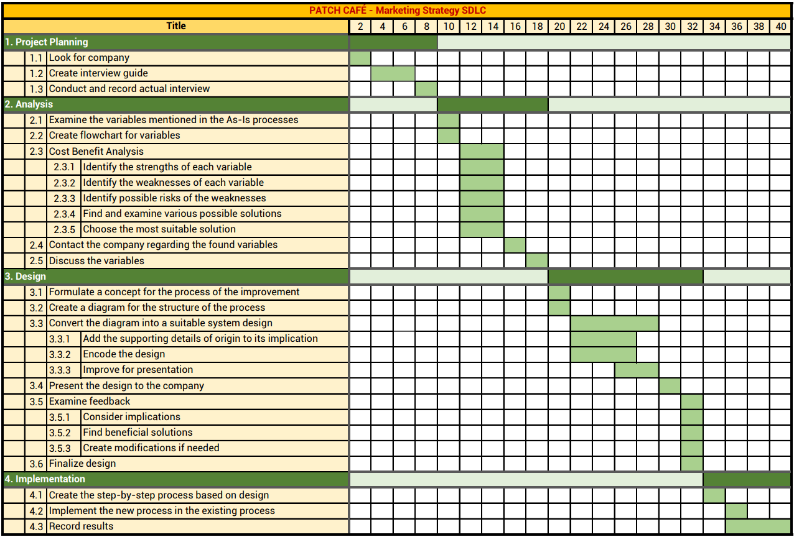

**PERT Chart**

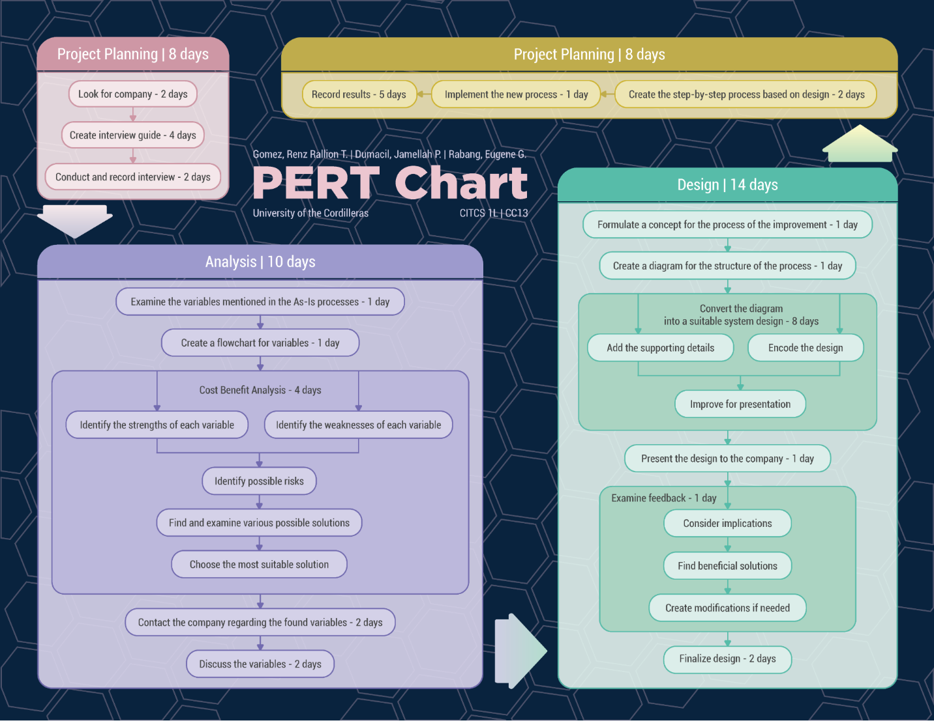

**Narrative As-Is Process**

**Key Notes:** ​The workplace has drastically changed and is currently still undergoing major changes.

**Marketing Strategies**

Patch Café’s secret in successful marketing is through the use of online resources to promote their products. The café never to rarely use printed advertising pamphlets to introduce their products to the public as based on their belief that it is not effective, it is limited and contributes to the environmental wastes. The following are the processes they use to market their products: 1. Patch first formulates a product promotion that is well suited for an upcoming event or the coming/current season which is mostly done by the manager and the kitchen staff. If it is necessary they consult third-party individuals such as their customers in the form of a checklist data gathering material. 2. They contact their sister branches across the country to inform them regarding the product promotion. Sometimes, they are the ones that are informed since their sister branches are also formulating their own product promotion ideas. 3. They contact their own graphic designer to create an enticing graphics to be posted on the social media platforms. 4. Most of their product promotions are done by posting publicly through Facebook and Instagram. They use their existing accounts to gain likes and shares from users who follow their page. Promotions Some of their past promotions are still being used today either as it is or they modify it. An example for it is the following process they use up until now: 1. The company chooses a partner. It can be a company holding an event or an individual who would like to be a partner for a specific event that the individual will host. (This process is optional since they can choose the regular customers). 2. The company formulates a certain amount of discount and some requirements to meet to get the discount, and offers it. 3. Once they agree on the deal, they can apply it hence benefiting both parties. Actual promotions they used:

1. The company offers a 10% discount for the frequent customers, in accordance with the SITEL Baguio, one of their partners, they propose at least worth of 300 for them to avail the promo.

2. They offer meals with a fixed price of Php. 99.00, called “99 Diners”, if the customer orders it between 11:00 am and 2:30: pm.

3. They offer additional free products for birthday events. They call these “Birthday Treats”. These products are pastries such as cookies and the sort.

4. They offer a 10% discount for the frequent or loyal customers. Partnership The main company or what they call the "mother company" is the Balingit Home Furnishing (BHF), which is a furniture company that offers any kind of furniture suits for your home. BHF controls and owns 100% of the company. One of the sister companies of the Patch Café is the BHF Pawnshop, also owned by BHF.

**Main Activities**

Patch Cafe is dependent when it comes to activities such as birthdays, weddings, and such. But they provide functions (meeting place) for hotel guests (Bloomfield).

**Problem of the Company**

The company's facing problem is their menu. The costing and pricing of food and ingredients that causes the unavailability of products. And also lacking of stacks that leads to loss of sales.

**Hierarchical**

The hierarchical company position consists of 4 positions, this includes the manager, dining unit head, chef, and the staff. To emerge as a successful organization, there should be a good coordination between all the above levels of management.

Under dining, kitchen, and staff. The current employees the Patch Cafe has 17 employees that contains 9 (nine) dining, 7 (seven) kitchens, and the manager.

**Range of Incomes**

The range of incomes of their employees depend on how long they work in the company. They increase their salary every year and in addition to that are their medical and life insurance, paid time off, and fringe benefit.

**WIREFRAME DIAGRAM**

The wireframe diagram defines the visual representation of objects or design of the system. The figure below consists of the different features of the system visually to obtain consent about the requirements.

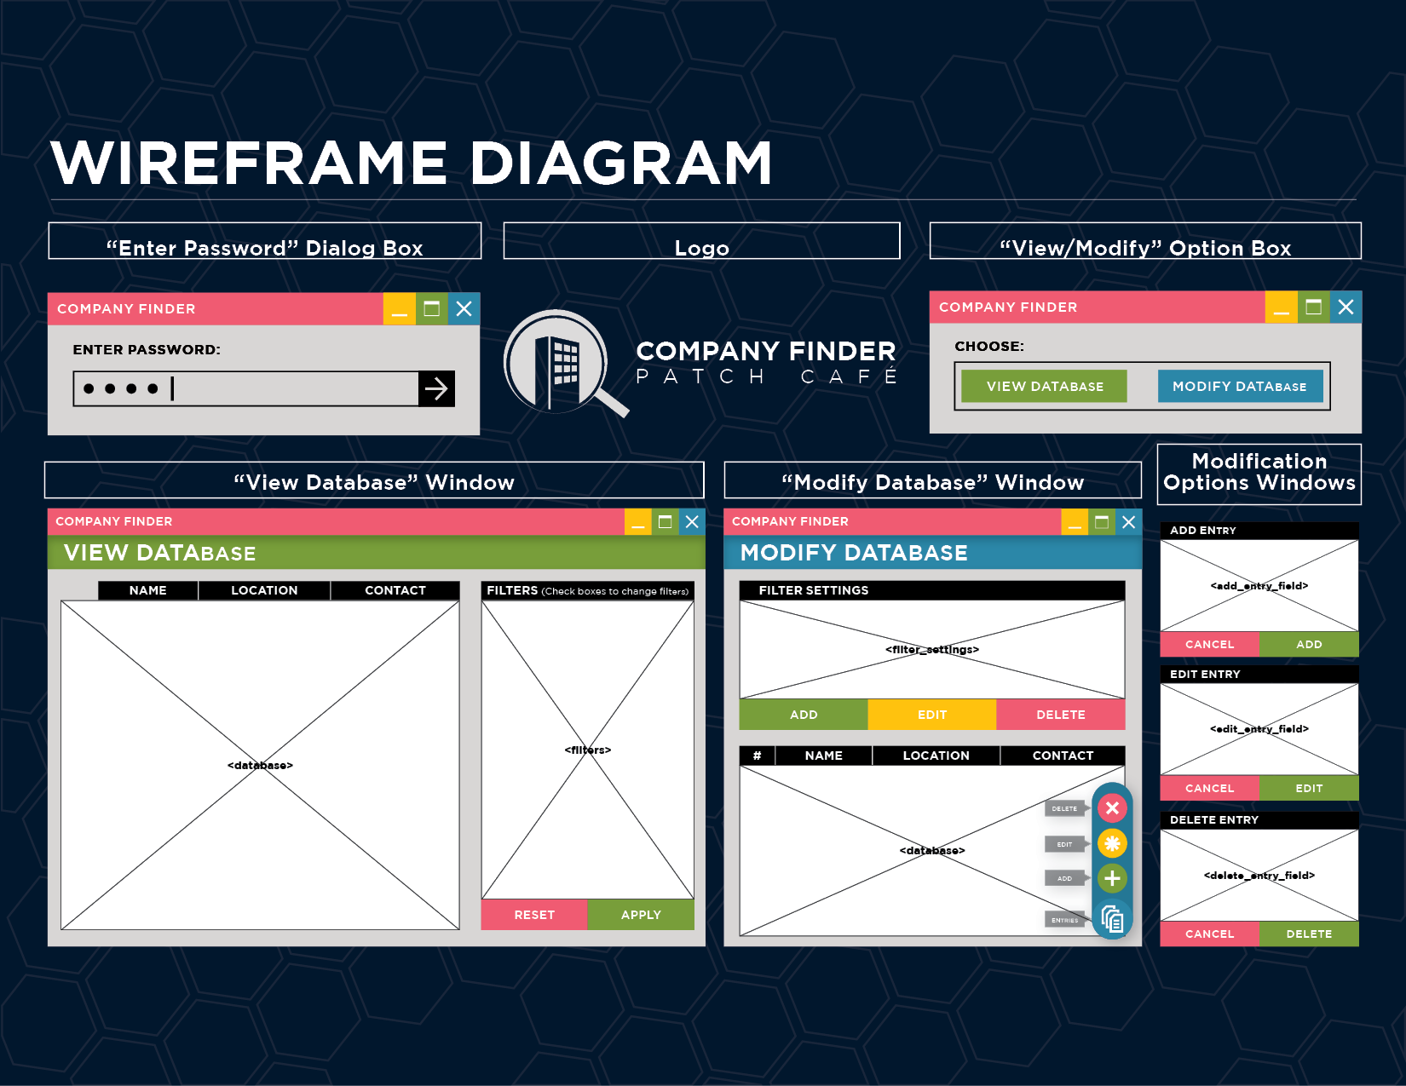

**AS-IS PROCESS FLOWCHART**

The As-is process flowchart defines the following procedures in marketing strategies. Patch cafe’s main legacy in their business are the following: Product Promotion Formulation; Report Distribution; Design Graphics; Posting on Social Media.

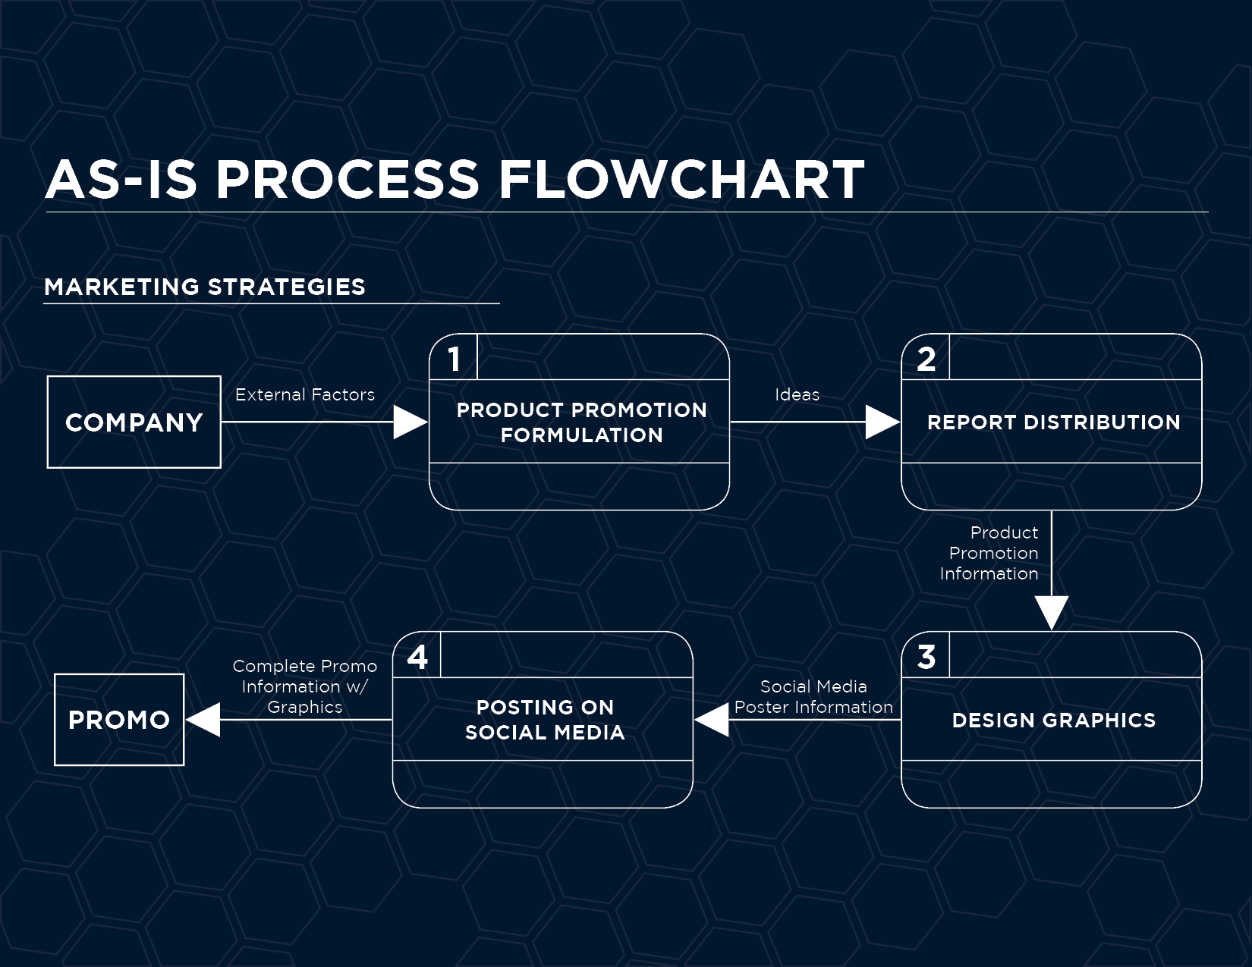

**AS-IS PROCESS CONTEXT DIAGRAM**

The As-is process context diagram clarifies the interfaces and boundaries of the project or the process. In the context diagram below, it shows the marketing strategy information system and it contains the Management and the Sister Branch for its product promotion information,and the Graphic Designer for its social media poster information.

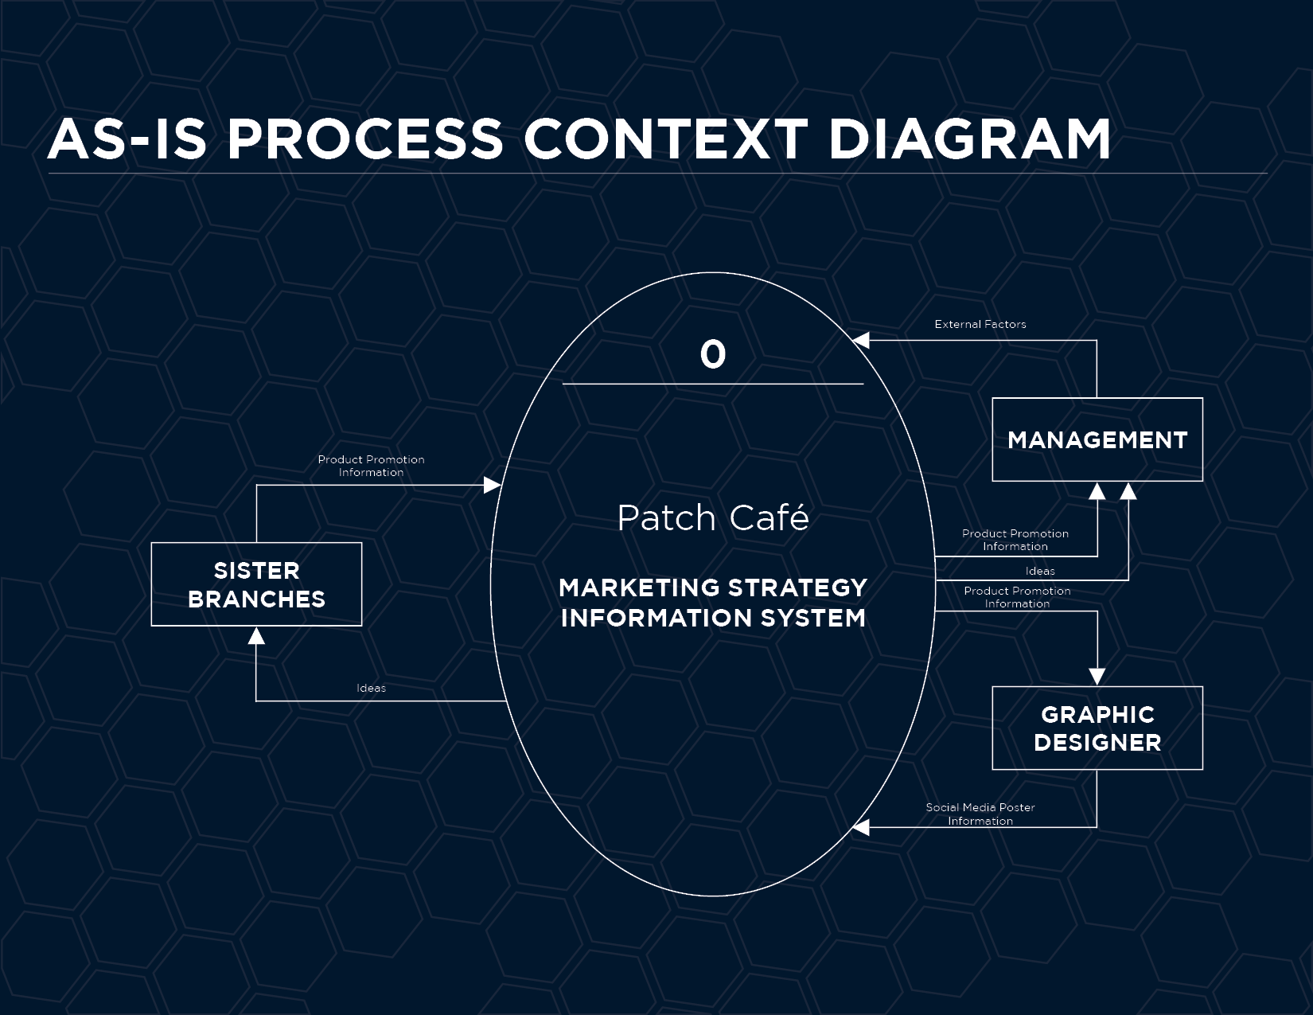

**AS-IS PROCESS TOP-LEVEL DIAGRAM**

The As-is process top-level diagram contains the railway of the company’s marketing strategies. It carries the process that represents the system to model, in this case, the “*Product Promotion Formulation*”, “*Report Distribution*”, “*Designing of graphics”*, and “*Posting on Social Media”.* It also contains the participants who interacts with the system, the graphic designer, and the management. The data in between the process and the entities are the existence of information exchange between the entities and the system.

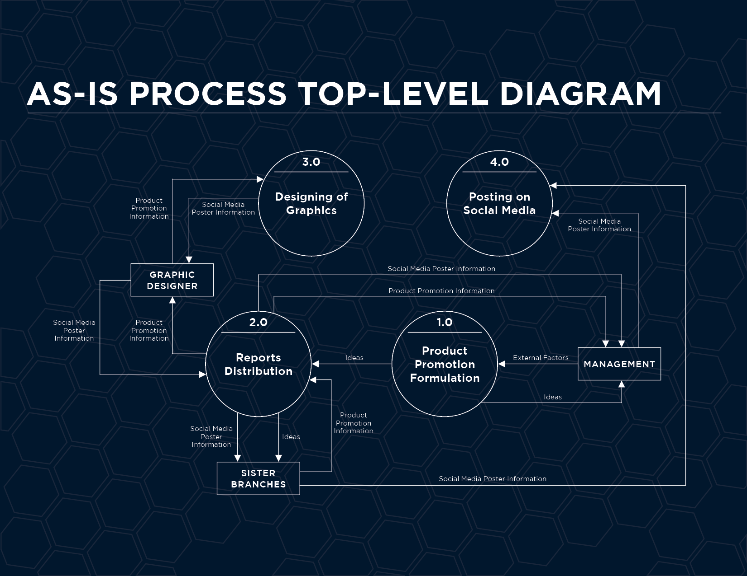

**ISHIKAWA DIAGRAM**

In the Ishikawa Diagram, it defines the visualization tool for categorizing the potential causes of a problem in order to identify the root causes and the following are the potential marketing strategy failure of Patch Cafe:

* Environment:
  1. Production Error that will lead to power shortage.
  2. Exposure of Prices that will lead to unsupervised facilities.
  3. Environmental Barriers that will lead to lack of privacy.
* Staff:
  1. Inexperienced staff that causes lack of training.
  2. Understaffed of employees because of seasonal changes, staffing needs may vary.
  3. For Leadership, it leads to lack of proper management.
* Systems:
  1. System Failure that will lead by unsupported actions.
  2. Machine Failure that will lead to hardware malfunctions.
  3. Absence of Needed Features that will lead to incomplete or poor programming skills.
* Communication:
  1. Absence of Communication that will lead to lack of established platform for communication.
  2. Interpretation of Data that will lead to unclear instructions.
  3. Assessment that causes dishonesty.

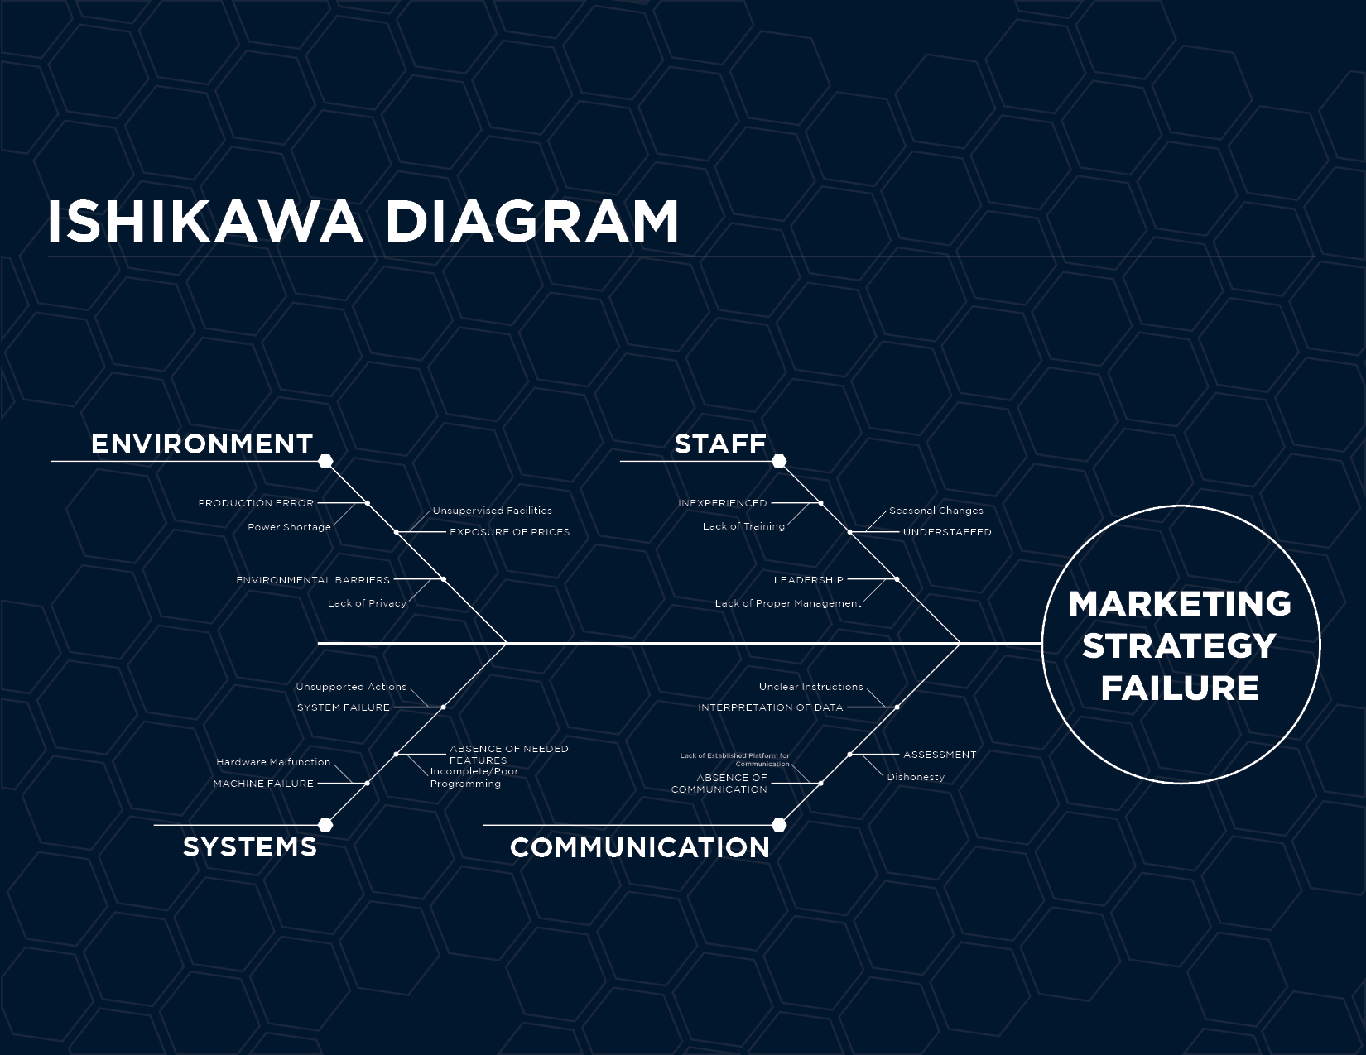

**SYSTEM USE-CASE DIAGRAM**

In the Use-Case Diagram, it shows the visualization of functional requirements of the system consisting of *View Criteria, View Results, Add Entry, Edit Entry,* and *Delete Entry.*

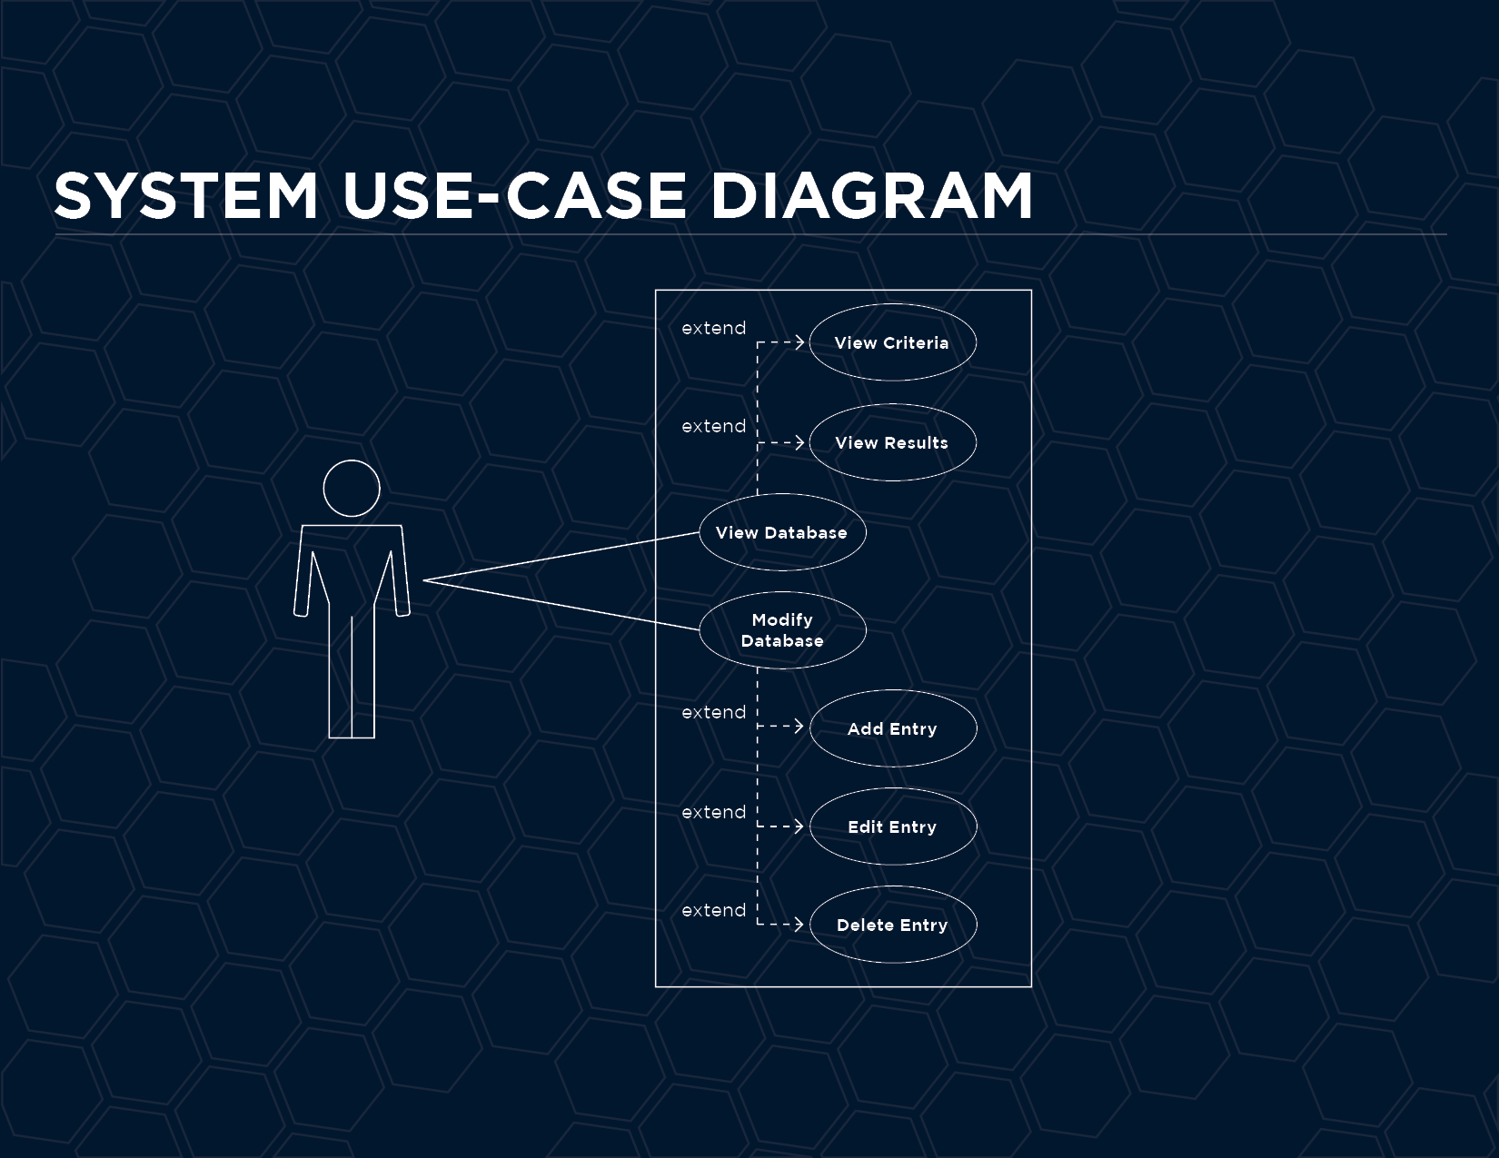

**Sequence Diagram - View Criteria** flow of events.

* The use-case diagram begins when the actor desires to enter the system.
* The actor provides password.
* The Application prompt "Enter Password" Dialog box.
* The Database Manager verify password. PasswordVerification().
* The Application identified the password and show success message.
* The Application prompt "View Database" and "Modify Database"
* The actor enter choice, if the actor entered "View Database", the Application open window for "View Database", else, the Application open window for "Modify Database".
* On completion of entry of the section request, the actor indicates that the request is complete or has been successful.
* The Application produces the criteria.
* The actor receives the Criteria list.
* If the actor provides wrong password. The database Manager verify the password. The application identified the password incorrect. The application who failure message.

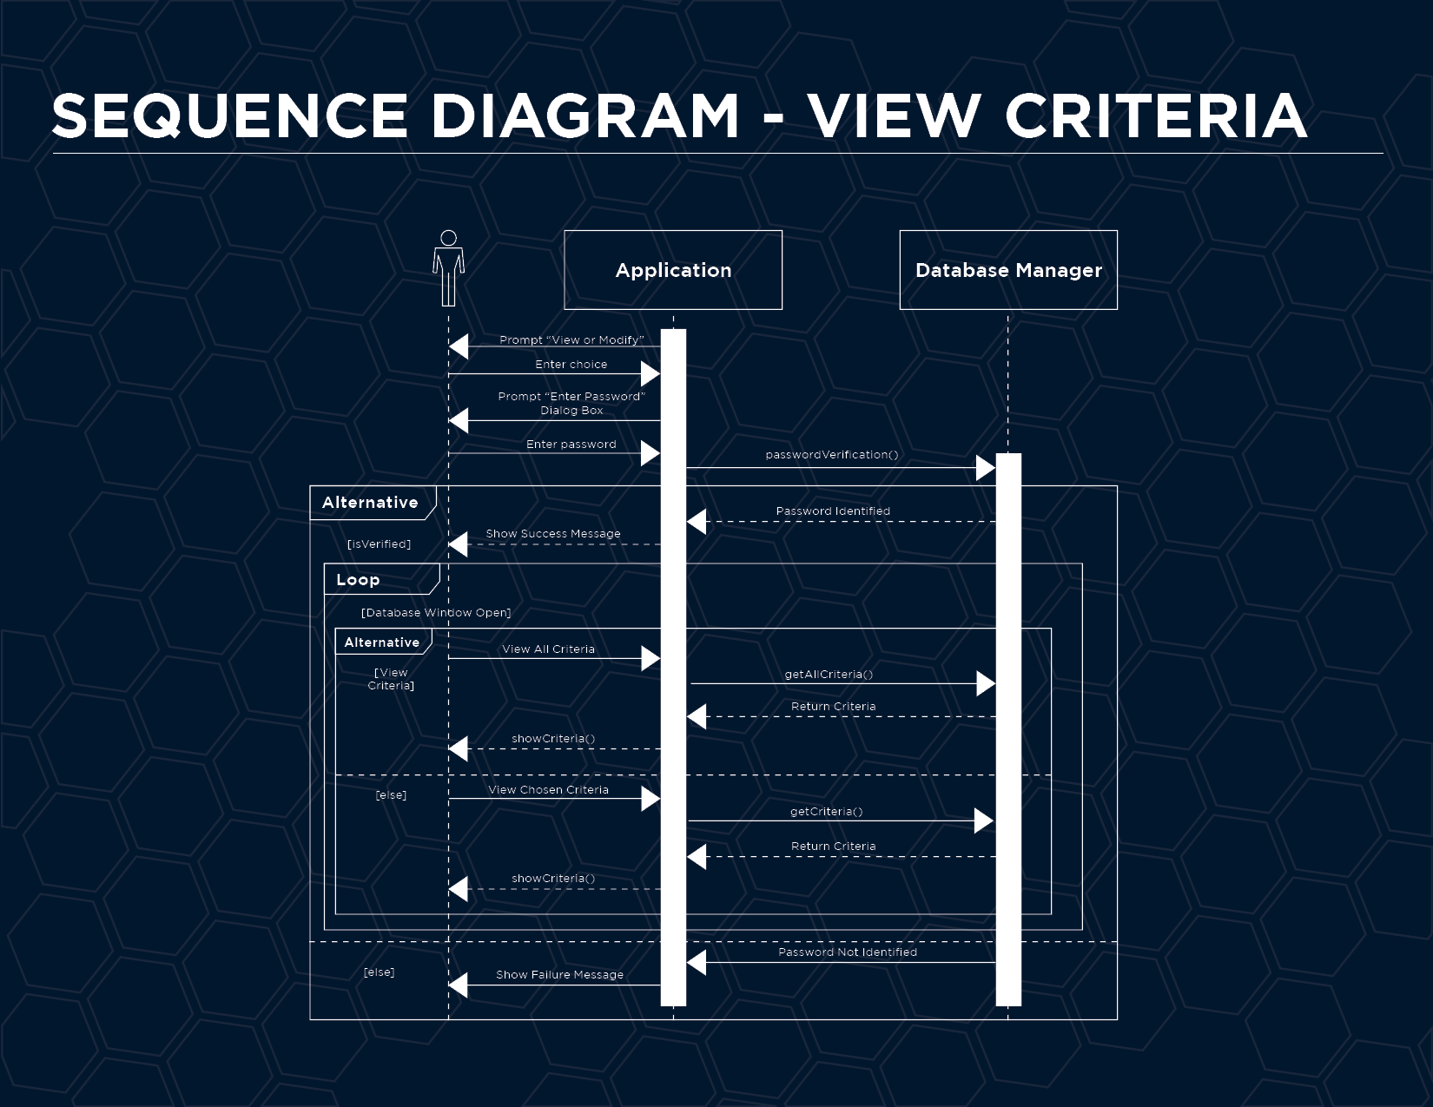

**Sequence Diagram - View Results** flow of events.

* The use-case diagram begins when the actor desires to enter the system.
* The actor provides password.
* The Application prompt "Enter Password" Dialog box.
* The Database Manager verify password. PasswordVerification().
* The Application identified the password and show success message.
* The Application prompt "View Database" and "Modify Database"
* The actor enter choice, if the actor entered "View Database", the Application open window for "View Database", else, the Application open window for "Modify Database".
* On completion of entry of the section request, the actor indicates that the request is complete or has been successful.
* The Application produces the results.
* The actor receives the Results.
* If the actor provides wrong password. The database Manager verify the password. The application identified the password incorrect. The application who failure message.

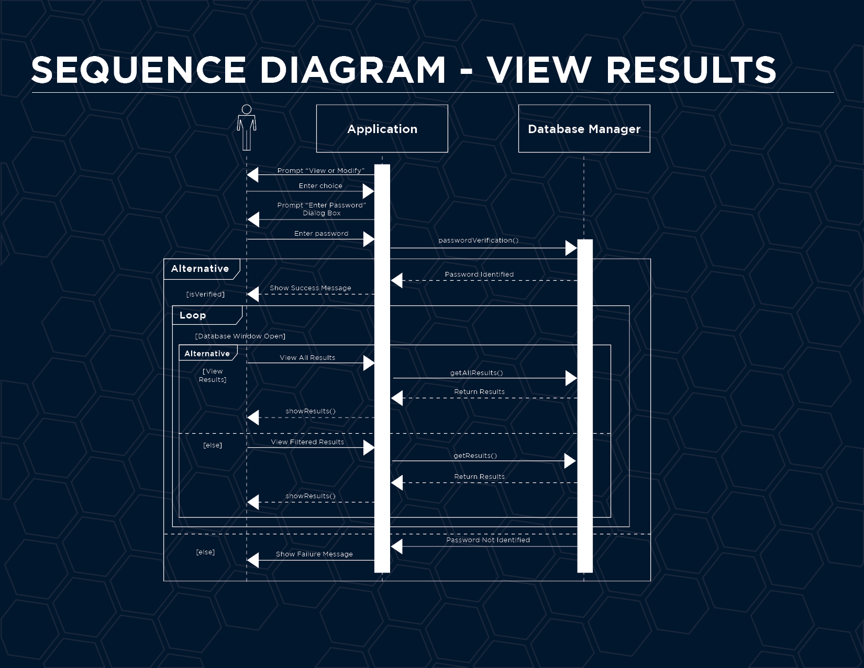

**Sequence Diagram - Add Entry** flow of events.

* The use-case diagram begins when the actor desires to enter the system.
* The actor provides password.
* The Application prompt "Enter Password" Dialog box.
* The Database Manager verify password. PasswordVerification().
* The Application identified the password and show success message.
* The Application prompt "View Database" and "Modify Database"
* The actor enter choice, if the actor entered "View Database", the Application open window for "View Database", else, the Application open window for "Modify Database".
* The actor add entry(s). The application adds the entry(s) and the database Manager verified successful addition. The application successfully show additional successful message.
* On completion of entry of the section request, the actor indicates that the request is complete or has been successful.
* The Application produces the entry.
* The actor receives satisfaction by adding entry(s).
* If the actor provides wrong password. The database Manager verify the password. The application identified the password incorrect. The application who failure message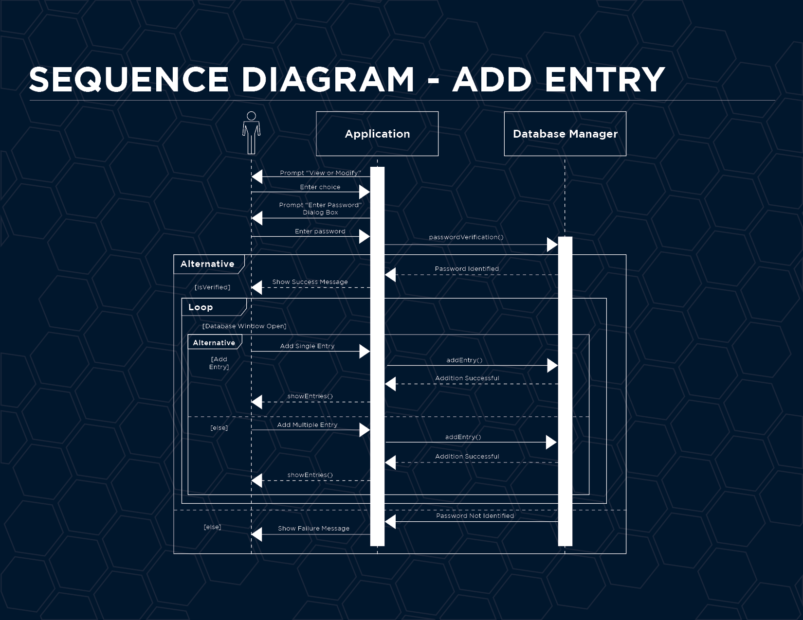

**Sequence Diagram - Edit Entry** flow of events.

* The use-case diagram begins when the actor desires to enter the system.
* The actor provides password.
* The Application prompt "Enter Password" Dialog box.
* The Database Manager verify password. PasswordVerification().
* The Application identified the password and show success message.
* The Application prompt "View Database" and "Modify Database"
* The actor enter choice, if the actor entered "View Database", the Application open window for "View Database", else, the Application open window for "Modify Database".
* The actor edit entry(s). The application edits the entry(s) and the database Manager verified successful edition. The application successfully show edition successful message.
* On completion of entry of the section request, the actor indicates that the request is complete or has been successful.
* The Application produces the entry.
* The actor receives satisfaction by adding entry(s).
* If the actor provides wrong password. The database Manager verify the password. The application identified the password incorrect. The application who failure message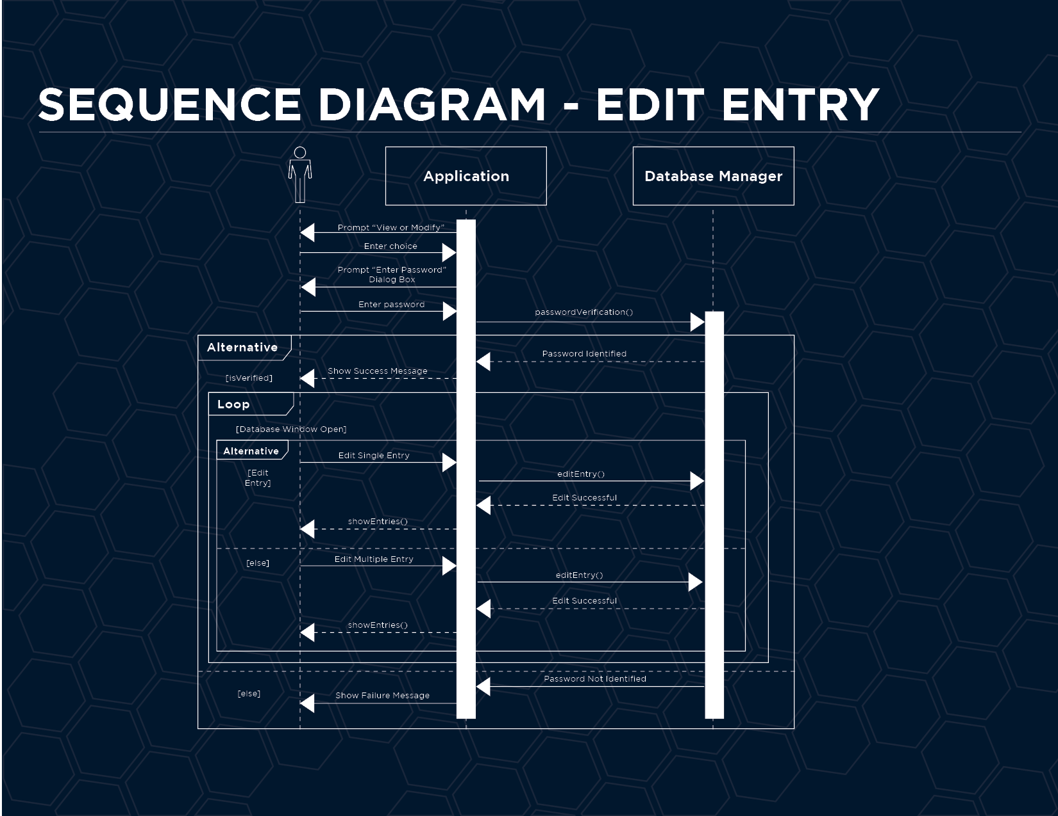

**Sequence Diagram - Delete Entry** flow of events.

* The use-case diagram begins when the actor desires to enter the system.
* The actor provides password.
* The Application prompt "Enter Password" Dialog box.
* The Database Manager verify password. PasswordVerification().
* The Application identified the password and show success message.
* The Application prompt "View Database" and "Modify Database"
* The actor enter choice, if the actor entered "View Database", the Application open window for "View Database", else, the Application open window for "Modify Database".
* The actor delete entry(s). The application delete the entry(s) and the database Manager successfully show deletion successful message.
* On completion of entry of the section request, the actor indicates that the request is complete or has been successful.
* The Application deleted the entry.
* The actor receives satisfaction by deleting entry(s).
* If the actor provides wrong password. The database Manager verify the password. The application identified the password incorrect. The application who failure message.

